- Three dimensional geometry
1. The figure below represents a plan of a roof with a rectangular base ABCD. AB = 20cm
and BC=12cm. the ridge PQ = 8cm is centrally placed. The faces ADP and BCQ are
equilateral triangles. N is the mid-point of BC
D
A
B
20cm
12cm
C
Q
P
8cm

Calculate:
(a) QN
(b) The altitude of P above the base
(c)The angle between the planes ABQP and ABCD
(d) (i) Locus P and locus Q meet at X. Mark X
(ii) Construct locus R in which angle BRC is 120º
(iii) Show that locus inside triangle ABC such that XS ≥ R
●
O
D
E
A
C
B
V
2.

The diagram alongside shows a right pyramid whose base is a
regular pentagon of side 10cm.VA=B=VC=VD=VE=18.2cm
and O is the centre of the pyramid. Calculate;

(a) height of the pyramid (b) area of the pentagon (c) angle between the face VAB and the base of the pyramid (d) The pyramid is a container filled with orange juice.
Calculate the amount of juice in it.
(e) find the surface area of the face VCD

3. The diagram below shows a right pyramid on a rectangular base ABCD measuring
7.5cm
D
C
B
A
V
7.5cm by 4.2cm.

4.2cm

If the volume of the pyramid is 52.5cm³, find:-
(i) The height of the pyramid
(ii) The length of a slanting edge correct to 1decimal place
(iii) The angle between AV and CV
(iv) The obtuse angle between the edges AB and VD

4. The figure below is cuboid ABCDEFGH. AB = 12cm, BC=5cm, CF = 6.5cm
F
E

6.5cm
M
G

H
D
C

5cm

A
B
12cm
Calculate:
(a) the length BD
(b) the angle AF makes with the base ABCD
(c) the angle DHGC makes with the base ABCD
(d) M is the mid-point of HE. Calculate the length of line MC and the angle line MC makes
with the base ABCD
5. The figure below is a right pyramid with a rectangular base ABCD and vertex V.
15cm
6cm
C
A
B
8cm
D
V
O

O is the centre of the base and M is a point on OV such that OM = ¹/₃ OV, AB = 8 cm, BC = 6 cm
and VA = VB=VD = VC = 15 cm. Find ;
i) The height OV of the pyramid.
ii) The angle between the plane BMC and base ABCD.

6. The figure below represents a right pyramid with vertex V and a rectangular base PQRS,
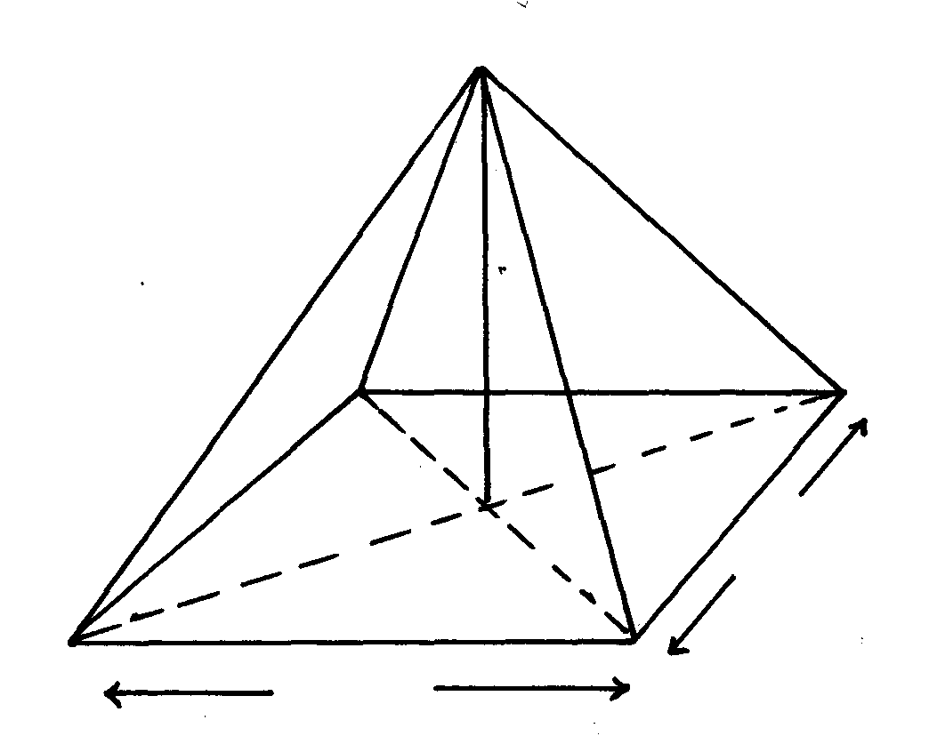
VP=VQ=VR=VS=18cm, PQ=16cm and QR=12cm. M and O are the midpoints of QR and PR
O
S
R
V
P
Q
16cm
12cm
18cm
respectively.

Find: a) the length of the projection of the line VP on the plane PQRS
b)the size of the angle between line VP and the plane PQRS
c) the size of the angle between plane VQR and PQRS

7. Mayoni Municipal Council wishes to construct a monument on the grounds. The monument
is designed to be in the shape of a frustrum of a right pyramid. The base of the frustrum is a
square of side 5.5meters while the top of the frustrum is a square of side 2.1cm
2.1m
2.1m
E
H
A
D
5.5m
5.5m
B
C
F
G

If the perpendicular distance between faces ABCD and EFGH is 7cm;
(a) find the surface area of the monument frustrum
(b) The monument is to be painted on all surface excluding the base. Paint is sold in 4 litre
tins each costing Kshs.640/=. It is estimated that an area 10m² is painted by ½ litre of paint,
find the cost of painting the monument.

8. The figure below is a pyramid of a rectangular base PQRS of length 12cm and width 9cm.
O
R
Q
S
P
19.5cm
9cm
12cm
The slanting edge has a length of 19.5cm

(a) Determine the height of the pyramid
(b) The angle PO makes with base PQRS
(c) The angle POS makes with QOR
(d) The volume of the pyramid

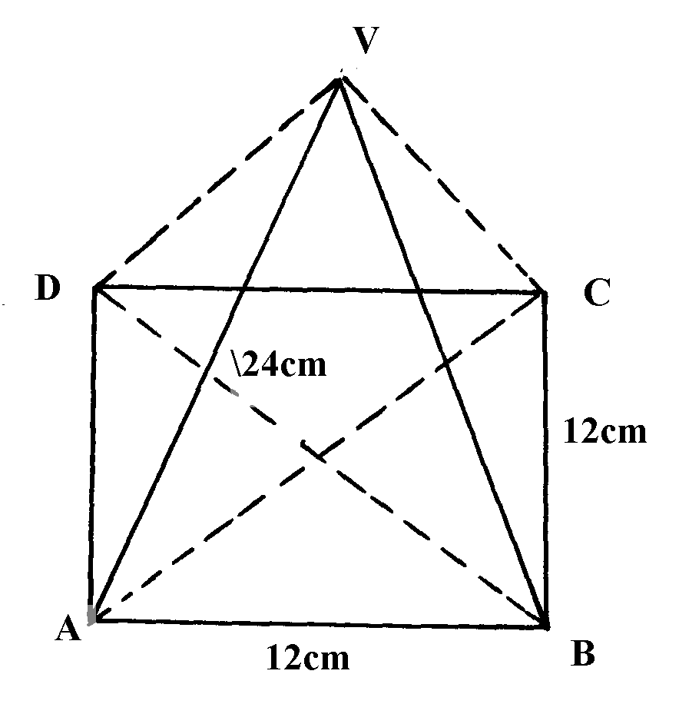
9. The diagram below shows a right solid pyramid on a square base ABCD of side 12cm and
slanting height of 24cm

Calculate;
a) To two decimal place the height (VO) of the pyramid
b) the volume of the pyramid
c) the total surface area of the pyramid

10. The base of a pyramid consists of a regular pentagon ABCDE, 4.5cm a side. The vertex
of the pyramid is V and VA = VB = VC = VD = VE = 6.4cm.
(a) Sketch the general view of the pyramid
(b) Calculate:
(i) The angle between VA and the base
(ii) The angle between face VCD and the base

11. The positions o two towns A and B on earths surface are (60°N, 139°E) and (60°N, 41°W) respectively
a) Find the difference in longitude between A and B
b) Given that the radius of the earth is 6370km, calculate the distance between A and B in KM
c) Another town C is 420km East of town B and on the same latitude A and B find the longitude
of town C

